Project Development PhaseSprint II

|  |  |
| --- | --- |
| Date | 7 November 2022 |
| Team ID | PNT2022TMID00922 |
| Project Name | Signs with Smart Connectivity for better road safety |

**SPRINT TARGETS:**

|  |  |  |  |  |  |  |
| --- | --- | --- | --- | --- | --- | --- |
| **Sprint** | **Functional Requirement (Epic)** | **UserStory Number** | **User Story / Task** | **Story Points** | **Priority** | **Team Members** |
| Sprint-2 | Safe Ride | USN-4 | As a traveler , I should have a hustie free journey | 20 | Medium | Adhithyan  dharun |

**Wokwi Simulation**: <https://wokwi.com/projects/348216301620036179>

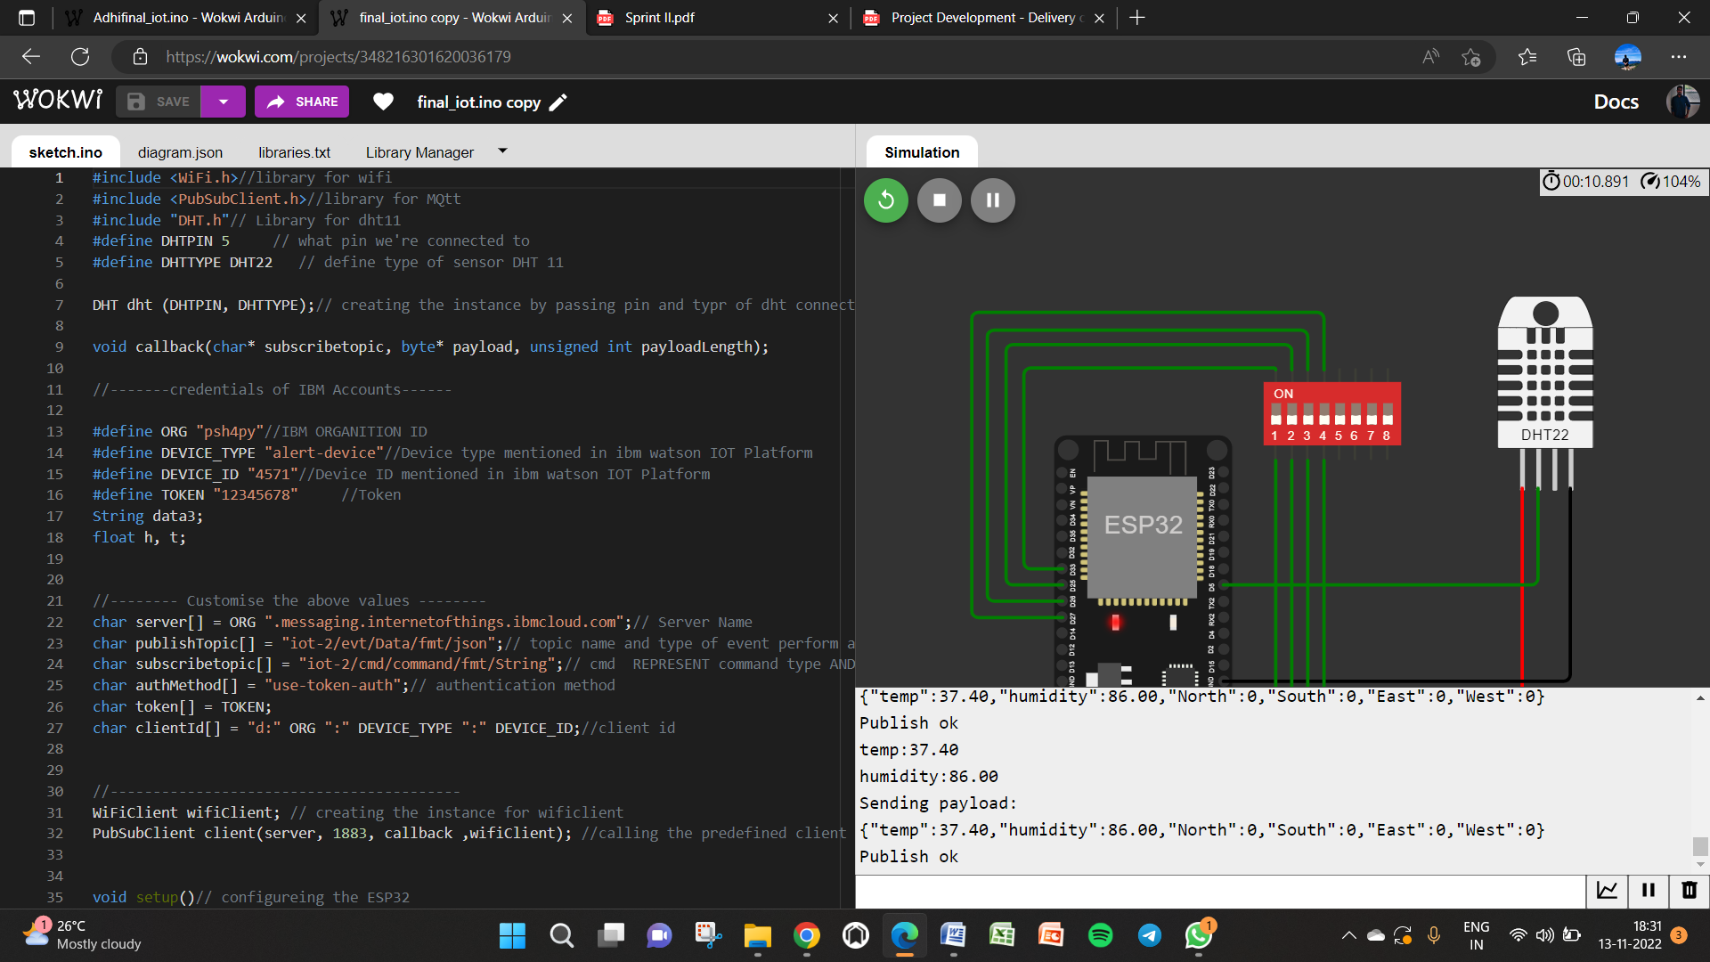

**IoT Device – IoT Platform**

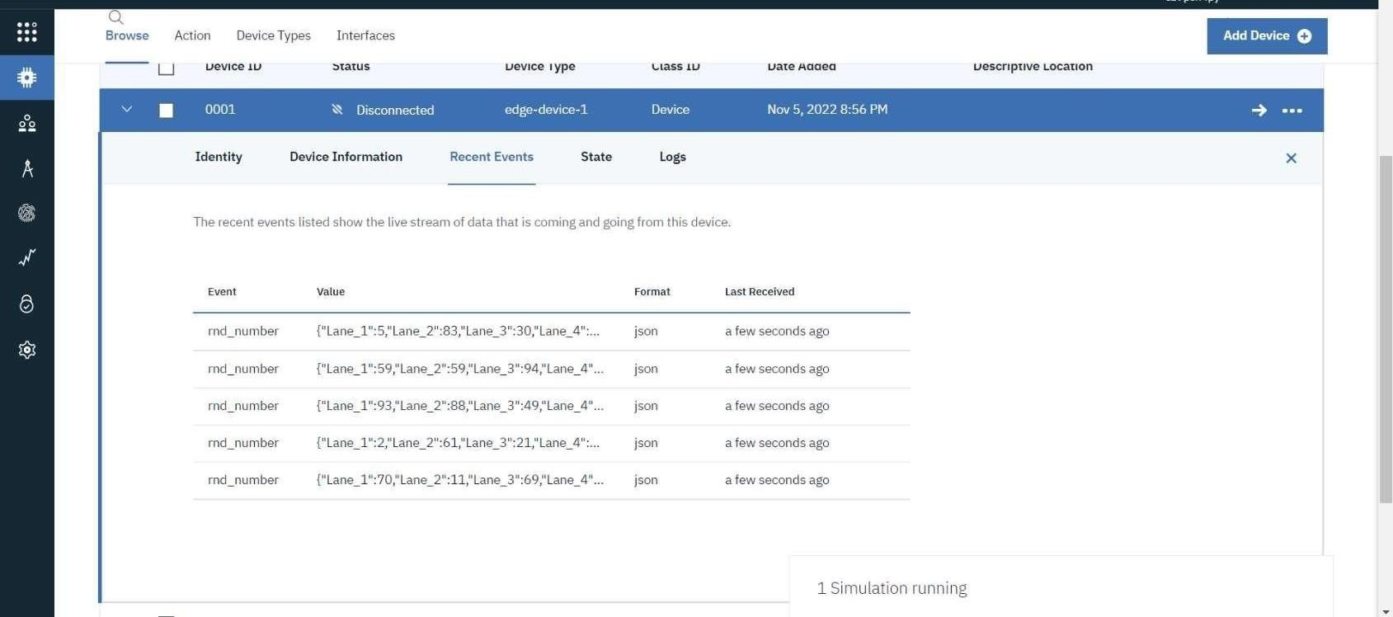

**Node Red**

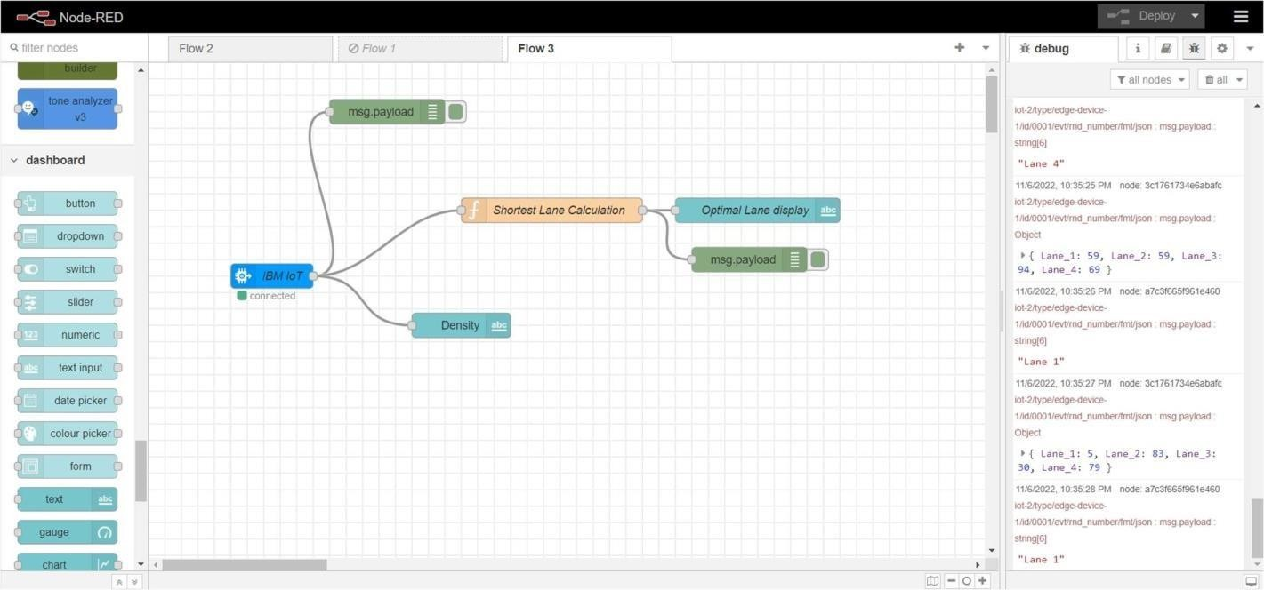

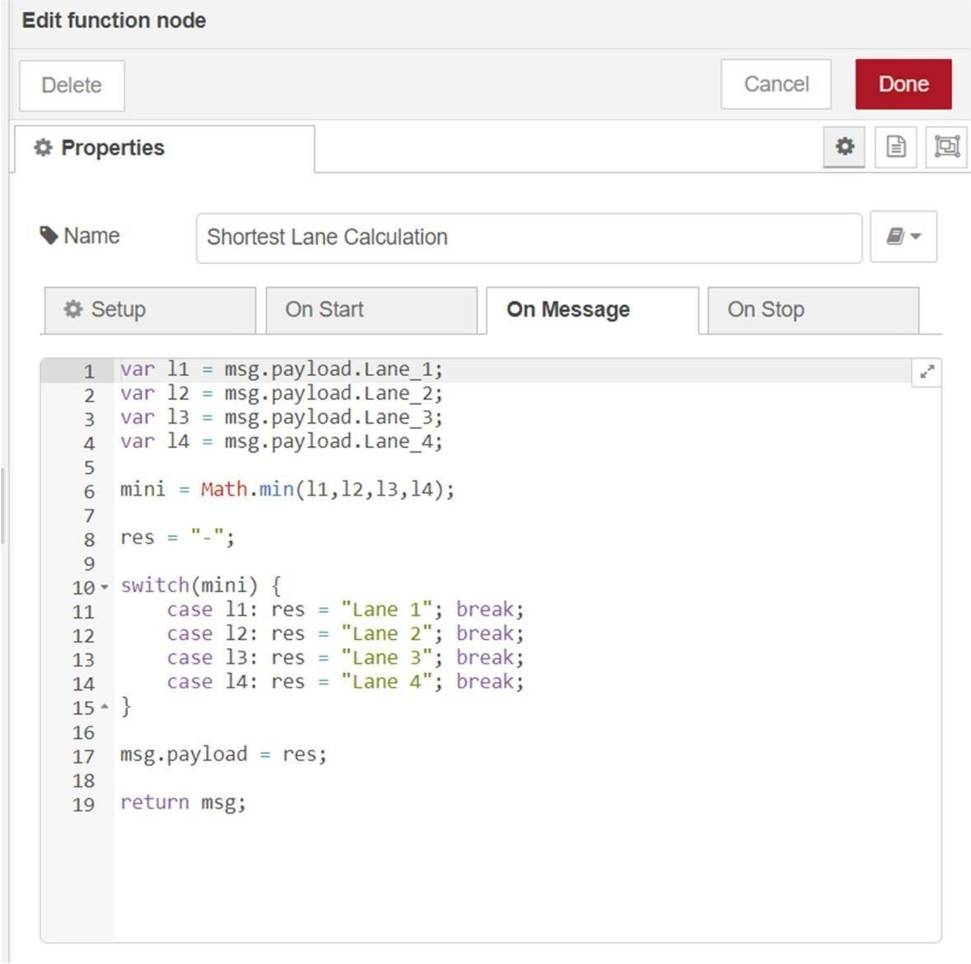

Node Red Web UI

